The for…in loop iterates over INHERITED properties too.

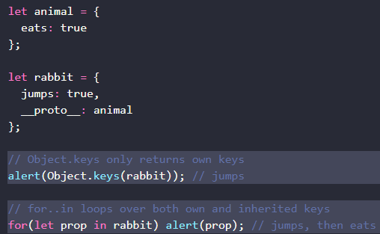

Object.keys – only returns own keys

For…in – returns both own and inherited keys

How to use for…in to return only own keys? Use hasOwnProperty() method

**.hasOwnProperty(*key*) method**

* Returns true if the object has its OWN property named *key*.
* Returns false if undefined or inherited

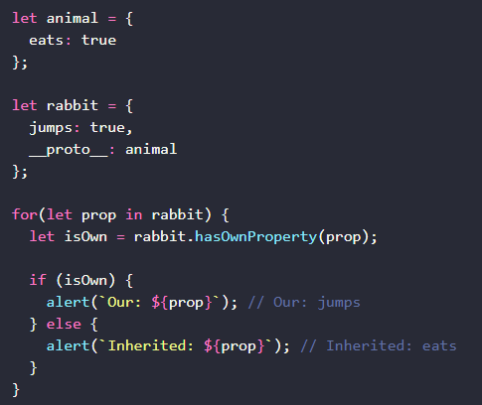

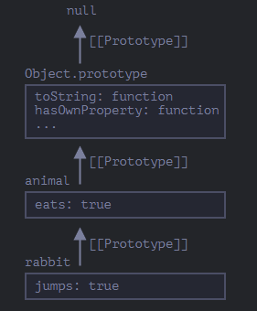

IMPORTANT NOTE:

All other properties of Object.prototype (the creator of them all) are NOT ENUMERABLE.

* That is why it does not return in a for…in loop even if all objects inherit from the Object.prototype

Object.keys, Object.values, and all other key/value-getting methods of Object.prototype

* IGNORE all inherited properties.
* They only operate on the object itself.